CSE 4571 – PRACTICAL ROBOTICS PROJECTS WITH ARDUINO
EXPERIMENT 4
STEPPER MOTOR POSITION AND DIRECTION CONTROL USING A4988
Duration | Level | Mode | CO Mapping
2 Hours | B.Tech CSE Final Year | Hardware / Wokwi | CO2, CO3
1. Aim of the Experiment
To interface a bipolar stepper motor with an A4988 driver and control its position and direction.
2. Objectives
- Understand STEP/DIR control.
- Generate controlled step pulses.
- Demonstrate direction reversal.
- Relate steps to angular position.
3. Components / Wokwi Parts
Component | Quantity | Purpose
Arduino UNO | 1 | Microcontroller / pulse generation
Bipolar Stepper Motor | 1 | Discrete-position actuator
A4988 Driver | 1 | Stepper driver / STEP-DIR interface
Breadboard | 1 | Circuit assembly
Jumper wires | As required | Interconnections
4. Theory
A stepper motor advances in discrete increments. The A4988 accepts STEP and DIR signals. Each STEP pulse advances the motor by a step, while DIR selects the direction. ENABLE controls whether the driver is enabled. Wokwi simulates the bipolar stepper and A4988 so that position and direction can be observed.
Number of steps × step angle → commanded angular displacement
5. Pre-Lab Questions
- What is a stepper motor?

- What do STEP and DIR mean?

- Why is a driver used?

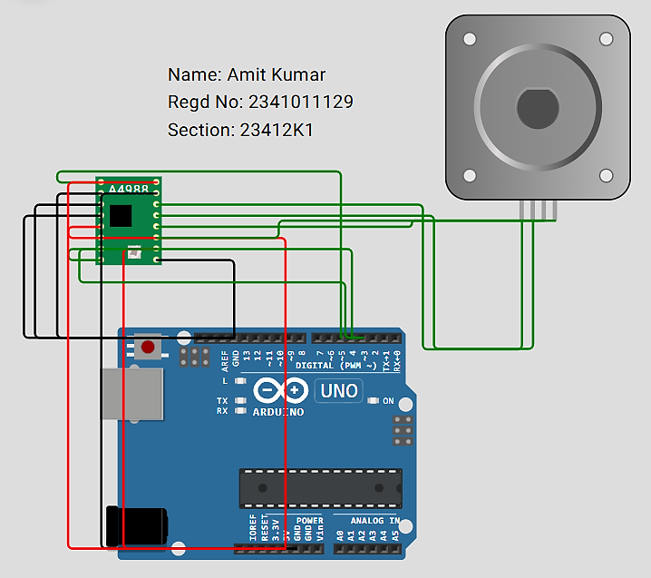
6. Circuit Diagram
Figure 1. A4988 STEP/DIR interface with bipolar stepper motor.
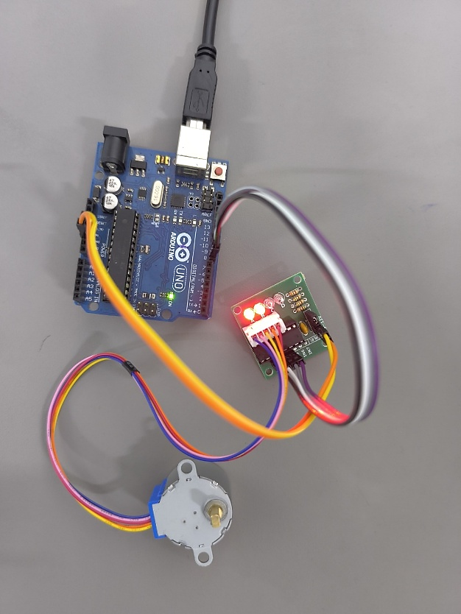
7. Connection Table
Signal / Component | Arduino Pin | Connection Details
STEP | D3 | A4988 STEP input
DIR | D4 | A4988 DIR input
ENABLE | D5 | A4988 ENABLE input
A4988 VDD | 5V | Logic supply
A4988 GND | GND | Common ground
Motor outputs | 1A, 1B, 2A, 2B | Two bipolar motor coils
RESET | SLEEP
SLEEP | 5V
M1,M2,M3 (Shorted) | GND
8. Circuit Diagram Implemented Using Hardware’s
Figure 2. Hardware Implementation of A4988 STEP/DIR interface with bipolar stepper motor.

9. Procedure
- Add the stepper and A4988.
- Connect logic supply and control lines exactly as shown.
- Connect the motor coils to the A4988 motor outputs.
- Run the program.
- Observe clockwise and counter-clockwise movement.
- Modify the step count and compare expected/observed angle.
- Record direction, step count and expected/observed angle.
10. Arduino Program
#define STEP_PIN 3
#define DIR_PIN 4
#define ENABLE_PIN 5
#define STEPS_PER_REV 100
void setup() {
pinMode(STEP_PIN, OUTPUT);
pinMode(DIR_PIN, OUTPUT);
pinMode(ENABLE_PIN, OUTPUT);
digitalWrite(STEP_PIN, LOW);
// Enable A4988
digitalWrite(ENABLE_PIN, LOW);
}
void moveMotor(int steps) {
for (int i = 0; i < steps; i++) {
digitalWrite(STEP_PIN, HIGH);
delayMicroseconds(1000);
digitalWrite(STEP_PIN, LOW);
delayMicroseconds(1000);
}
}
void loop() {
// Clockwise
digitalWrite(DIR_PIN, HIGH);
moveMotor(STEPS_PER_REV);
delay(1000);
// Counter-clockwise
digitalWrite(DIR_PIN, LOW);
moveMotor(STEPS_PER_REV);
delay(1000);
}

11. Observation Table
Sl. No. | Direction | Steps | Expected Angle | Observed Angle
1 | Clockwise | 100 | 180° | 180°
2 | Anticlockwise | 100 | 0° | 0°
3 | Clockwise | 100 | 180° | 180°
4 | Anticlockwise | 100 | 0° | 0°
5 | Clockwise | 100 | 180° | 180°
12. Expected Output / Analysis
The program commands 100 steps in one direction, waits one second, then commands 100 steps in the reverse direction. The motor therefore alternates between the two directions. The actual angular displacement depends on the step angle represented by the simulated motor configuration.
13. Result
The bipolar stepper motor was successfully interfaced with the A4988 driver in Wokwi. STEP/DIR control, direction reversal and the relationship between commanded steps and angular movement were verified.
14. Post-Lab Questions
- Command a 90° movement.

- Add a potentiometer to change step rate.

15. Precautions
- Verify pin assignments before running the simulation.
- Use common ground for connected devices.
- Record both input condition and observed output.
- Do not change STEP, DIR and ENABLE pins without updating the program.
- For physical implementation, consider current, voltage, motor loading, driver configuration and thermal requirements.

16. Suggested Extension
Modify the program to add one meaningful feature, document the change, and preserve the original behavior as a baseline.
Suggested Extension: The program was modified to command a 90° angular movement by generating 50 STEP pulses. The original 100-step clockwise / counter-clockwise operation was preserved as the baseline.
#define STEP_PIN 3
#define DIR_PIN 4
#define ENABLE_PIN 5
#define STEPS 100
#define STEPS_90 50
void setup() {
pinMode(STEP_PIN, OUTPUT);
pinMode(DIR_PIN, OUTPUT);
pinMode(ENABLE_PIN, OUTPUT);
digitalWrite(STEP_PIN, LOW);
digitalWrite(ENABLE_PIN, LOW);
}
void moveMotor(int steps) {
for (int i = 0; i < steps; i++) {
digitalWrite(STEP_PIN, HIGH);
delayMicroseconds(1000);
digitalWrite(STEP_PIN, LOW);
delayMicroseconds(1000);
}
}
void loop() {
// Original experiment: 100 steps clockwise
digitalWrite(DIR_PIN, HIGH);
moveMotor(STEPS);
delay(1000);
// Original experiment: 100 steps counter-clockwise
digitalWrite(DIR_PIN, LOW);
moveMotor(STEPS);
delay(1000);
// Extension: 90° clockwise
digitalWrite(DIR_PIN, HIGH);
moveMotor(STEPS_90);
delay(1000);
// Extension: 90° counter-clockwise
digitalWrite(DIR_PIN, LOW);
moveMotor(STEPS_90);
delay(1000);
}

17. Student Record

Amit Kumar | 2341011129
Student Name | Registration No. | Date | Faculty Signature

